|  |  |  |
| --- | --- | --- |
| **LAB 321 Assignment** | **Type:** | **Long Assignment** |
| **Code:** | **J3.L.P0002** |
| **LOC:** | **300** |
| **Slot(s):** | **10** |

**Title:** Airline Tickets

**Background**

Have you ever travelled by airplane or booking a plane ticket? Let try how to make a website for booking online an eticket.

**Program Specifications**

Program an airline tickets, detail functions of this website is described below

**Features:**

This website contains 4 main functions; there are two kinds of users: guests and registered users.

As the registered users you are allowed to use all functions of system.

As the Guest you are allowed to use function 5 only.

* Function 1: Home page ( see figure 01)
  + There are three menu on navigation bar: Home (current page), Book, Manage Booking and added two small menu on the right top of the website named Login and Register
  + To be able to use the function of each menu, users are required to login the system first. If you wish to have an account, you can make a new one by click on hyperlink Register
* Function 2: Login page ( see PIC 02)
* Function 3: Booking page ( see PIC 03)
  + Firstly, search for a flight that you wanna book, including departure date and return date. You book flight for yourself only.
  + After select the flight and click on **Save** button, save information of Flight to database and automatically generate the booking number or reservation code of booking.
* Function 4: Manage Booking ( see PIC 04)
  + Display information of all bookings that you have just done.
* Function 5: Register a new user ( see PIC 05)
  + Register a new user

Note: All data must be load from database, not hard code.

***Expectation of User interface:***

Pic 01: Home Page ( TOP)

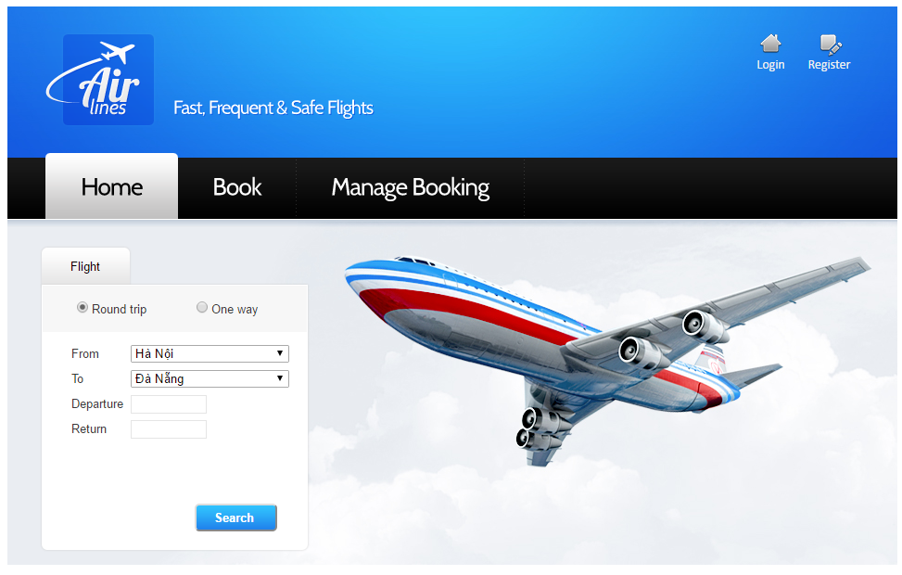

PIC 02: Login Page

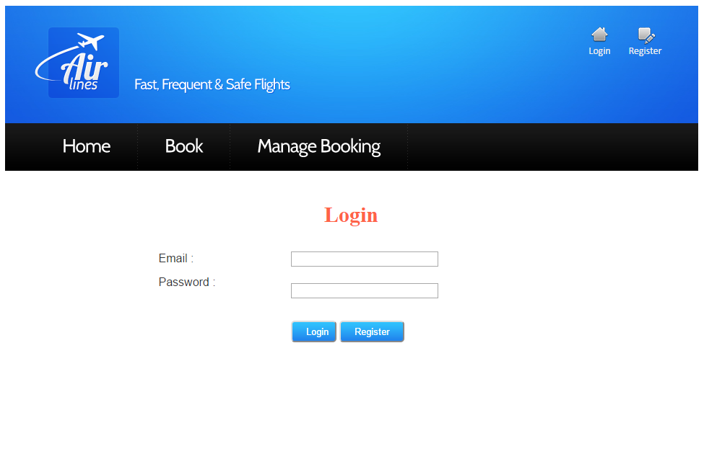

Pic 03: Booking page

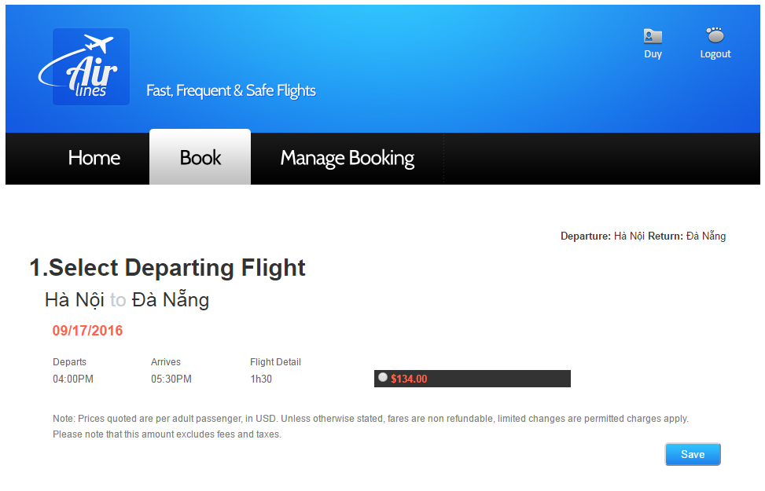

PIC 04: Manage Booking

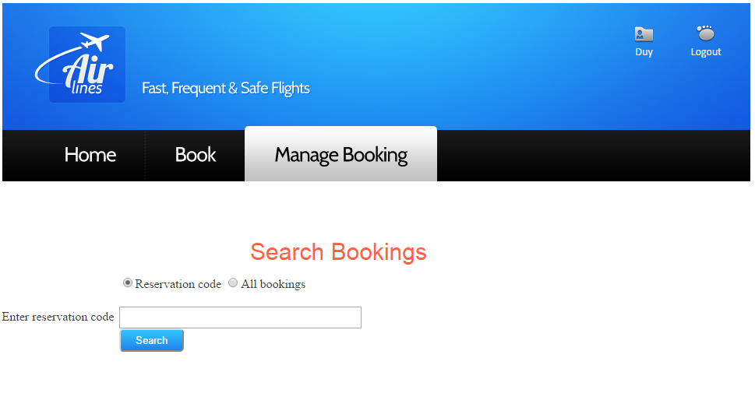

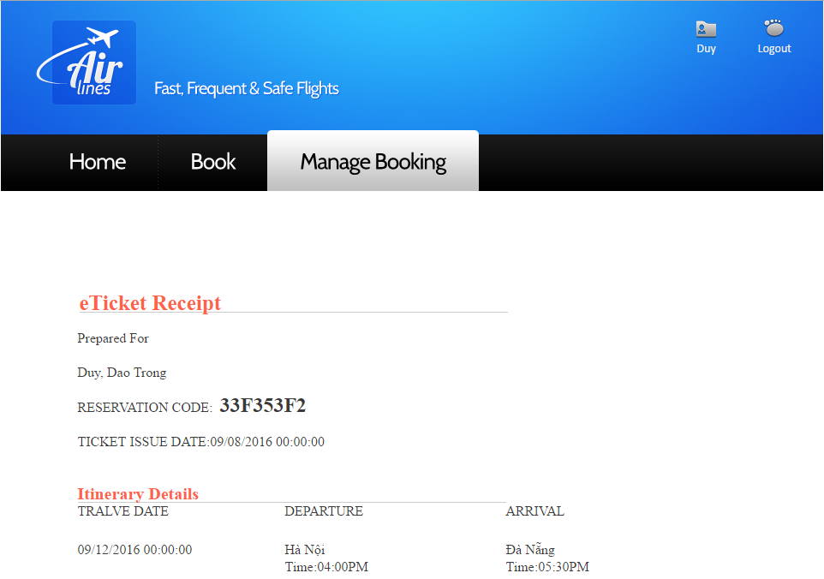

PIC 05: Register Page

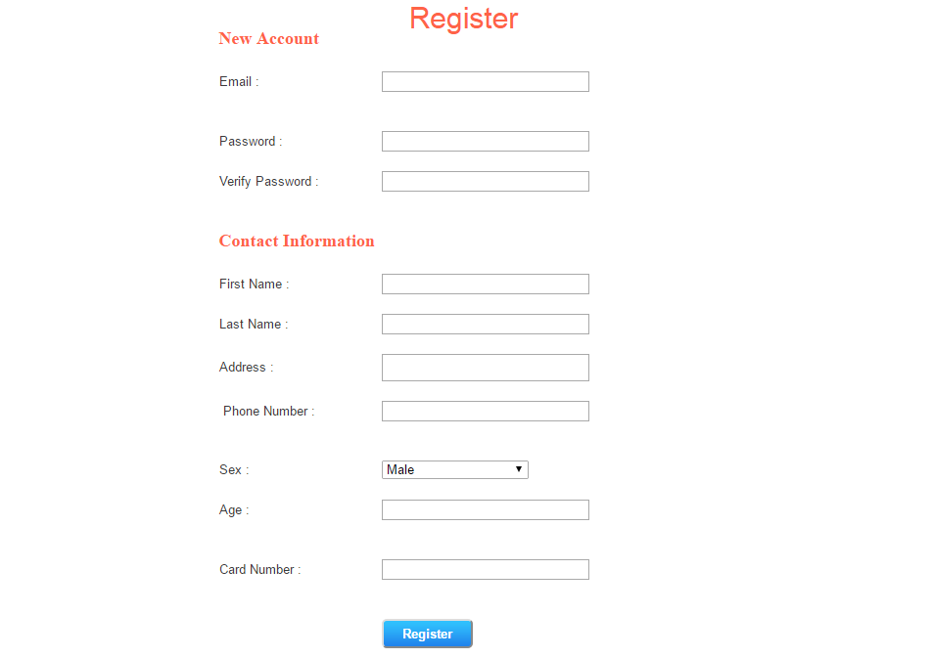

**Guidelines**

* Step 1 : Create prototype
* Step 2 : Design database based on created prototype
* Step 3 : Code & Test